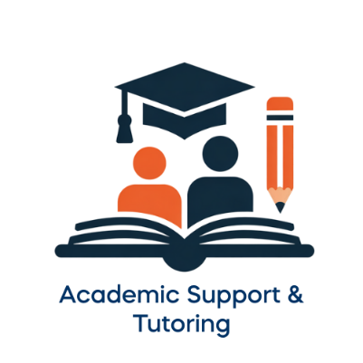

Academic Support & Tutoring is here to help students with their coursework needs. As a part of the Learning Commons (housed in the Learning Technology Center), AST provides in-person and online support to students as they strive to be independent learners pursuing success.

Some of our services include:
- Essay/Writing Help
- Math & Accounting Assistance
- Content Support & Tutoring (All Subjects)
- Supplemental Instruction (group study sessions attached to some classes)
- Learn about Brightspace, Student Email, MyMathLab, MyMCC, and more Classroom Technologies
- Presentations & Workshops

Students wishing to book an appointment can search by subject or availability using Upswing at mclennan.upswing.io for 24/7 tutoring online and during business hours in the Learning Commons. Walk-ins are always welcome.

