[Ensemble Name]

[Name], conductor

[Day, Month Date, Year | Time]
Wilbur A. Ball Performing Arts Center

[Ensemble Name]

Title (Date) Composer (Date/s)

Title (Date) Composer (Date/s)

Title (Date) Composer (Date/s)

Title (Date) Composer (Date/s)

Title (Date) Composer (Date/s)

Title (Date) Composer (Date/s)

Title (Date) Composer (Date/s)

The use of all cameras and recording devices is strictly prohibited.
Please turn off all cell phones and pagers or set ringers to silent mode.

[Section]
[Names]

McLennan Community College Music Faculty & Staff

Mandy Morrison, Director of Visual and Performing Arts
Jon Conrad, Music Area Coordinator
Jonathan Kutz, Music Industry Careers Program Director
Meghan Wilfong, Senior Administrative Assistant
Bradley Christian, Dean of Arts and Sciences

Ensembles
Noah Alvarado, jazz
Jon Conrad, bands
Jenna McLean, choir
Clark Nauert, jazz
Peter Olson, orchestra
Edgar Sierra, opera
Arthur Torres, mariachi

Music Industry Careers
Jon Fox
Shane Hall
Brian Konzelman
Jonathan Kutz
Maddison Livingston
Patrick McKee
Clark Nauert

Winds
Tristen Collinsworth, bassoon
Vanessa Davis, clarinet
Matthew Fowler, trombone
Clay Garrett, euphonium/tuba
Kim Hagelstein, horn
Masha Popova, flute
Mark Schubert, trumpet
Matthew Singletary, saxophone

Percussion
Jonathan Kutz

Strings
Ben Cantrell, violin/viola
Kate Cockle, harp
Peter Olson, bass

Piano
Jared Eben
Ping-Ting Lan
James Pitts
Voice
Jenna McLean
Mandy Morrison
Edgar Sierra

Musicology & Theory
Kate Cockle
Jared Eben
Kim Hagelstein
Jenna McLean
Mandy Morrison
Peter Olson
James Pitts
Matthew Singletary

Administrative Staff
Randy Dockendorf,
Theatre Technician
Nick Webb, Box Office

See all Upcoming Performances in the Department of Music.
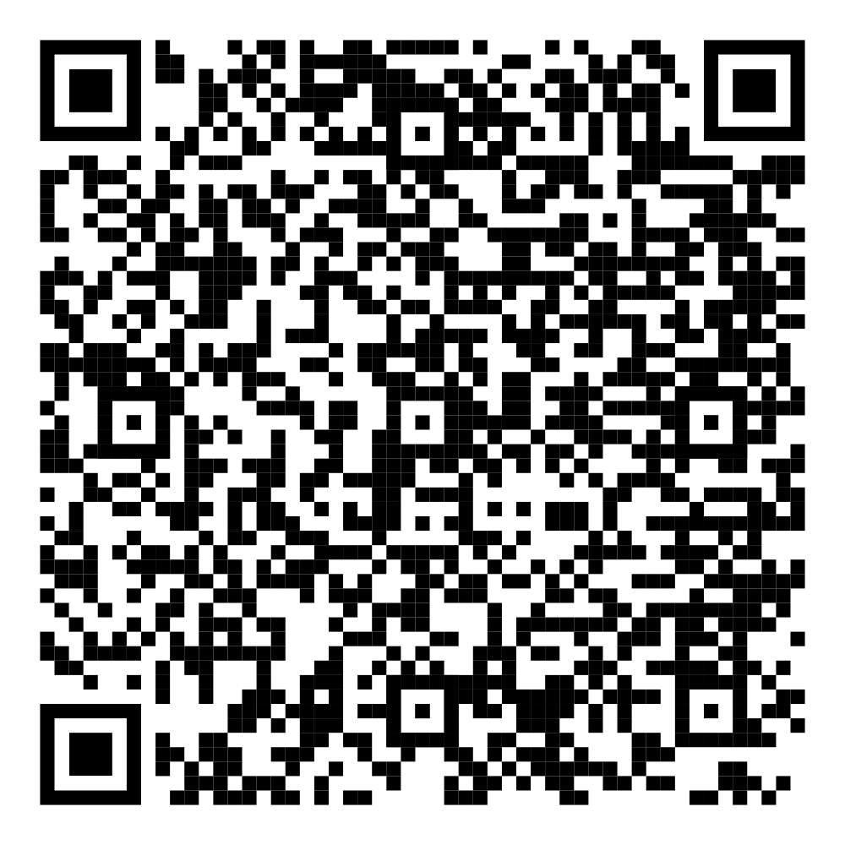
Join our Emailing List and receive information on upcoming performances.

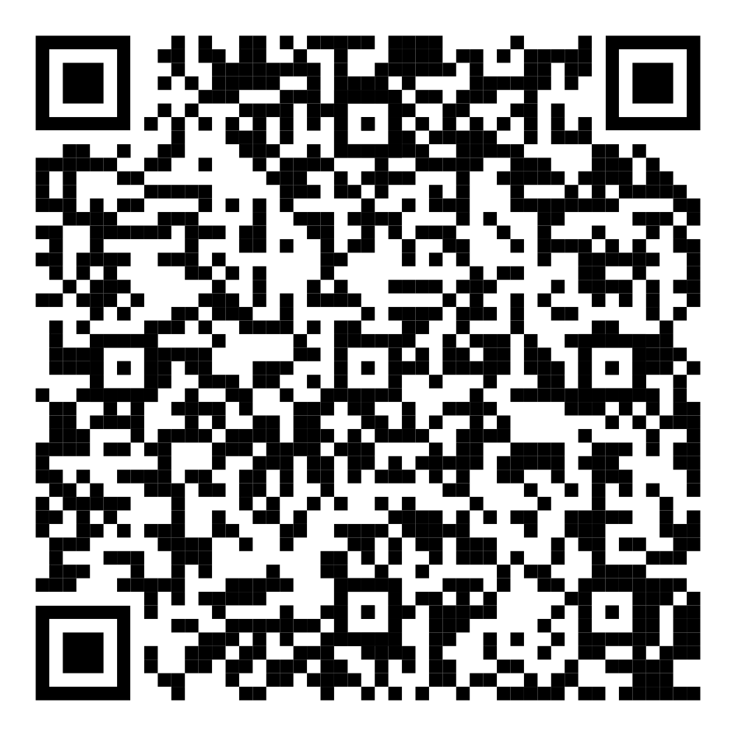

Join the Hearts in the Arts or support our students through a gift to the MCC Foundation.

