News Coverage Report: Sept 1 – Oct 22, 2024
September
- Students hear 10th Court of Appeals cases at McLennan Community College KWTX 10
- This has probably been our busiest year | McLennan Community College is asking for help filling their food pantry KCEN 6
- McLennan Community College to debut new volleyball program in 2025 KXXV 25
- McLennan adding women's volleyball for fall of 2025 Waco Trib
October
- High school notebook: Centex volleyball coaches offer thumb's up to MCC's addition Waco Trib
- McLennan Community College students participate in disaster simulation KWTX 10
- Tornado simulation tests MCC paramedicine, nursing students' preparedness Waco Trib
- Students’ skills are put to the test in a mass-casualty simulation KWKT FOX 44
- McLennan Community College post-pandemic enrollment rebounds Waco Trib
- MCC Foundation scholarship applications open through Jan. 15 Waco Trib
- PHOTOS: McLennan Madness kicks off MCC athletics year Waco Tribune-Herald
- Cybersecurity Awareness Month Interviews with KWTX 10
  - www.kwtx.com/video/2024/10/10/cybersecurity-awareness-month-kwtx4-way-protect-yourself-cybersecurity-scam-1017/
  - www.kwtx.com/video/2024/10/18/cybersecurity-awareness-week-kwtx4-social-media-safety-101824/

Note: The above does not include additional stations/media that picked up original articles or sports coverage.
Prepared by Jennifer Marshall-Higgins, Director, Marketing & Communications

Tornado simulation tests MCC paramedicine, nursing students' preparedness
McLennan Community College students in the paramedicine and associate degree nursing programs respond Thursday to a mass casualty simulation of a tornado’s aftermath. In multiple rotations throughout the day, students tested their preparedness, triaging people with injuries and transporting some in the school’s ambulance to the Health Professions Simulation Building for further treatment.

Rod Aydelotte photos, Tribune-Herald

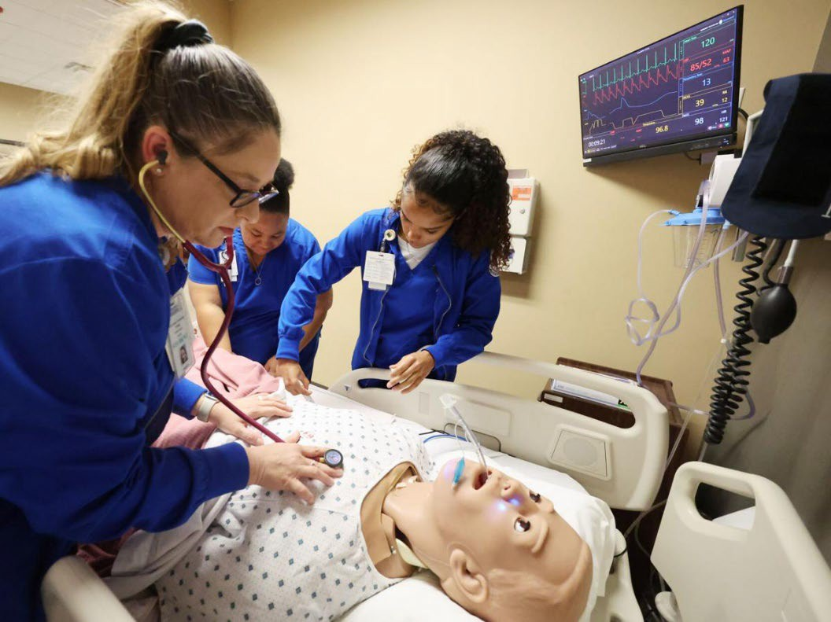
Victims in MCC's mass casualty simulation Thursday were taken to the Health Professions Simulation Building, where students work in a critical care area, a trauma area and two 10-bed simulation wards complete with one-way mirrors and audio-video recording equipment for instructors to observe students' performance and review it with them.

Students prepare a victim in Thursday's mass casualty simulation to be transported for further treatment.

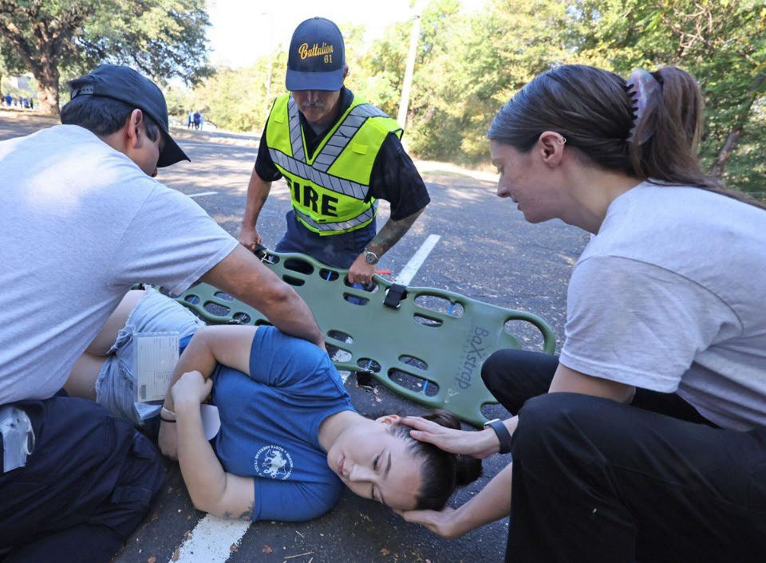
Students prepare a victim in Thursday's mass casualty simulation to be transported for further treatment.

MCC students load a victim in Thursday's mass casualty simulation into the school's ambulance.

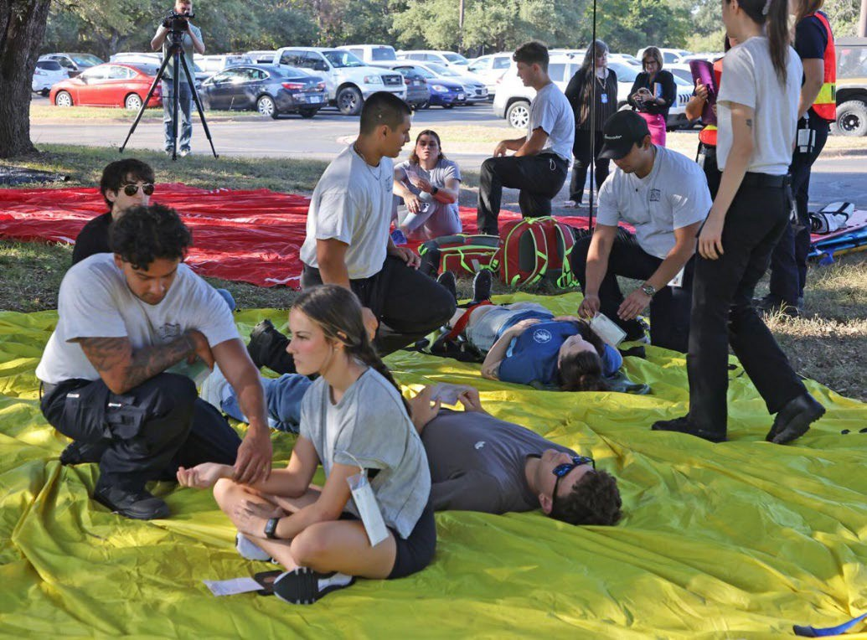
McLennan Community College students in the paramedicine and associate degree nursing programs respond Thursday to a mass casualty simulation of a tornado's aftermath. In multiple rotations throughout the day, students tested their preparedness, triaging people with injuries and transporting some in the school's ambulance to the Health Professions Simulation Building for further treatment.

MCC students training in emergency medical response gather at the school's ambulance for a mass casualty simulation Thursday.

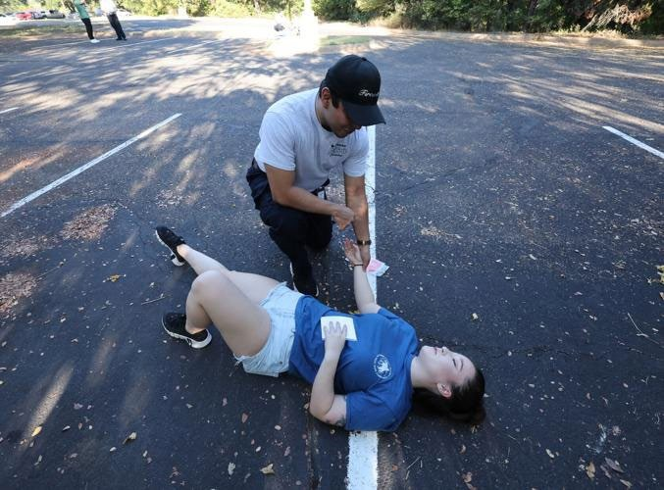

McLennan Community College students in the paramedicine and associate degree nursing programs respond Thursday to a mass casualty simulation of a tornado's aftermath. In multiple rotations throughout the day, students tested their preparedness, triaging people with injuries and transporting some in the school's ambulance to the Health Professions Simulation Building for further treatment.

10/25/24, 1:07 PM Critical Mention

 Dashboard Mentions Search Alerts Analytics Contacts Files
marcom@mclennan.e…
Help

Oct 16, 2024 1:03 AM CDT Neu.

Enrollment slump turns around; McLennan Community College post-pandemic enrollment rebounds

Distributed by Newsbank, Inc. All Rights Reserved Copyright 2024 Waco Tribune-Herald.

Source  Waco Tribune-Herald (Texas) | Language  English
Market
Waco, TX
Type
Print
Category
Local
Author
CARL HOOVER choover@wacotrib.com

McLennan Community College's fall enrollment has topped 8,000 students for the first time in four years, signaling a rebound from the impact of the 2020 pandemic.

Fall enrollment taken Sept. 24 showed 8,046 students enrolled at the community college, the highest level since fall 2020 when 8,029 students were enrolled.

The fall 2024 numbers, however, are considerably below the college's record enrollment of 10,414 students in spring 2020.

In addition to the positive enrollment numbers presented to college trustees at their Sept. 24 meeting, the college also saw its retention rates hold steady or slowly improve.

The fall to spring retention rate, the percentage of students who continue their classes after their first semester, held steady at 77.7%, nearly identical to last year's 77.6% rate. The fall to fall retention rate, which measures the students who return after their first year, rose slightly from 64.8% last year to 65.2% this year.

Laura Wichman, MCC vice president for strategic planning and enrollment, said the higher enrollment and retention rates show the impact of a program that followed up on students who had not registered after being accepted, as well as heightened attention paid to students struggling with their classes.

A program run by education enrollment firm Motimatic found more than 300 people had been accepted by MCC over the last two years, but had never registered for classes. The Motimatic program used social media advertising to remind that group to register for classes, and many did.

The college also contacted students who had dropped out for non-payment of tuition and fees and, in some cases, connected them to scholarship support or other financial resources.

Wichman said MCC faculty and support staff paid special attention to students struggling with their grades, informing them of academic help available and non-academic services for those juggling their studies with family or work responsibilities.

"For students who make Ds, Fs or Ws (withdrawals) in all of their courses, we've found they are highly unlikely to come back," she said.

At the same time, MCC worked with some who had dropped out several years ago to encourage them to return to college, this time with an awareness of the services available to help them through, she said.

A shift in state funding for community colleges last year put less emphasis on enrollment numbers than the success of students in finishing degree programs, continuing to four-year colleges or earning job certifications. The college's work to increase its retention rates should pay off in more students completing their education and training goals, Wichman said.

MCC board Chair Earl Stinnett Sr. said the fall enrollment numbers show the result of the Strategic Enrollment Program the board had approved to 1/2

10/25/24, 1:07 PM Critical Mention
stop and repair the enrollment slump of the last few years. "I certainly think it's positive," Stinnett said.
Efforts to streamline student enrollment, financial aid and other services also played a part by lowering student frustration, a reason some first- time students would give up and quit.
"You have one shot to make an impression on them," Stinnett said. MCC's spring registration will start next month.

10/25/24, 1:12 PM Critical Mention

Dashboard Mentions Search Alerts Analytics Contacts Files
marcom@mclennan.e…
Help

Oct 8, 2024 10:36 PM CDT Pos.

Scholarship applications for MCC; Scholarship applications for MCC

The McLennan Community College Foundation is currently accepting scholarship applications for the 2025-26 academic year through Jan. 15, 2025.
Language
English
Category
Local

The MCC Foundation bestowed $775,895 in student scholarships for the 2024-25 academic year and awards scholarships based on merit, need, academic major, high school, employer and many other specific criteria, managing more than 600 separate scholarship funds.

"Putting college opportunity within reach of area students is our mission at the MCC Foundation," said Wes Livesay, the foundation's executive director. "Thanks to the incredible generosity of community donors, we have been able to increase the number and amounts of awards we are able to make, and we encourage anyone who is thinking about attending college at MCC to apply."

Applications are online at mclennan.awardspring.com.

Students must have an MCC-issued student ID and email address.
A second application period will be available from May 1-15, 2025, but not all scholarship opportunities will be available then.

10/25/24, 1:24 PM McLennan Community College adding volleyball for 2025

https://wacotrib.com/sports/college/mcc/waco-mcc-volleyball-mclennan-community-college- highlanders/article_11a3c3b2-7f3c-11ef-976c-bfdcfa573e96.html
EDITOR'S PICK
McLennan adding women's volleyball for fall of 2025
Brice Cherry
Sep 30, 2024
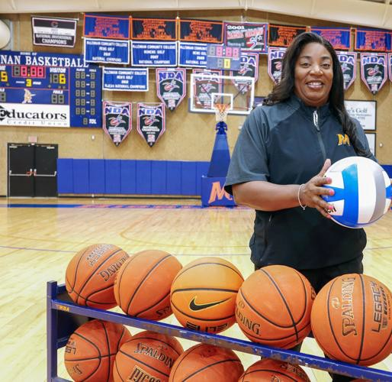
MCC athletic director Shawn Trochim said that adding women’s volleyball will help the athletic department in reachi
Rod Aydelotte, Tribune-Herald

Brice Cherry

https://wacotrib.com/sports/college/mcc/waco-mcc-volleyball-mclennan-community-college-highlanders/article_11a3c3b2-7f3c-11ef-976c-bfdcfa573e9… 1/5

10/25/24, 1:24 PM McLennan Community College adding volleyball for 2025
T
he time is coming for the McLennan Community College Highlanders to rise high above the net — and we’re not talking about basketball.
MCC will introduce women’s volleyball as its eighth sport in 2025, marking the first new sport for the college in nearly 25 years. McLennan unanimously approved the addition of volleyball at its board meeting last week, and announced the move via a press release on Monday.
“When I took this position, which it’s been 20 years now, this has always been on my radar, the expansion of the athletic department,” MCC athletic director Shawn Trochim said. “It was important for me to make sure that we’re always in compliance with Title IX, providing equal opportunity for our female athletes as well as our male student athletes, and it finally became the right time to embark on this.”

Indeed, MCC noted that the addition of women’s volleyball will help the athletic department line up better with the demographic ratio of the student body, which is 68 percent female and 32 male. The makeup in MCC’s athletic department is currently nearly reversed, at 62 percent male and 38 percent female.

It shouldn’t be too hard for MCC to find volleyball opponents. In NJCAA Div. I, Region V consists of 16 other schools already fielding women’s volleyball squads — Amarillo, Cisco, Clarendon, Frank Phillips, Hill, Midland, New Mexico, New Mexico Military, North Central Texas, Odessa, Ranger, Southwestern Christian, Temple, Vernon, Weatherford and Western Texas. All but the two New Mexico teams reside in Texas.
There are also a number of Texas junior colleges that play in Region XIV, including Blinn, Coastal Bend, Lee, Navarro, Panola, Trinity Valley, Tyler and Wharton County.

MCC will join Region V and play in the North Texas Junior College Athletic Conference — familiar territory, since it’s the same league in which MCC already plays basketball. That conference will consist of Weatherford, North Central Texas, Hill, Ranger, Vernon, Temple, Cisco and Southwestern Christian in addition to the Highlanders.

“We’ve actually got more teams in the conference that play volleyball than play basketball, with us and the addition of Collin County in 2025,” Trochim said.
Volleyball will become McLennan’s eighth sport, as it also currently has teams for men’s and women’s basketball, men’s and women’s golf, baseball, softball, and the national championship-winning dance team, which MCC includes under its athletic umbrella. Before volleyball, the last sport MCC added was softball in 1999-2000.
Volleyball, specifically, has been on Trochim’s radar for a while as a potential addition. In fact, Jonathan Hill, a member of McLennan’s Board of Trustees, was a student intern back in 2013 who worked with Trochim on a feasibility study about adding volleyball.

“This program is not just a win for our student-athletes and the campus community; it’s a testament to the years of hard work and vision led by our outstanding athletic director, Shawn Trochim,” Hill said in a statement. “Volleyball players are historically high-achieving, high-character student leaders — that was true when we evaluated the program during my time as a student in 2013, and it’s still true today. I can’t wait for the Waco community to show out and support elite collegiate volleyball at The Highlands.

Next up for Trochim and MCC will be finalizing the job description for the new head volleyball coach and assistant coach positions, and then embarking on a “nationside search” for the candidates for those positions. The plan would be to start the first season in the fall of 2025.
“Our administration, our President and Vice President, they understand the importance of what athletics brings to campus,” Trochim said. “It changes our financial structure to add sports, but I’m glad they saw the need, and was absolutely ecstatic that the board unanimously approved this when I had the opportunity to present it to them.
“One of the things I shared with them is that our sports that we have right now, we really don’t get rolling until November, and this gives us a chance to get some excitement going early in the semester, to start capturing some of those new students, even as soon as Labor Day. We’re really excited what this will mean moving forward.”

INTERVIEW: McLennan Community College athletic director Shawn Trochim oversaw a tremendous year of success in Highlander and Highlassie country in 2022, and she’s being rewarded as the Tribune-Herald Sportsperson of the Year.

EDITOR'S PICK
HS NOTEBOOK
High school notebook: Centex volleyball coaches offer thumb's up to MCC's addition

When McLennan Community College announced this week that it would be adding women’s volleyball to its athletic offerings for 2025, it was a move that was applauded by many around Central Texas.
Perhaps the loudest ovation came from Central Texas high school coaches.
More college programs offering volleyball leads to more scholarship opportunities for high school players, including those from the fertile volleyball land of Central Texas.
“I think it’s a great addition to the Waco area for local players,” Lorena head coach Andee Little said. “It’s super exciting!
West High School is situated relatively equidistant between Hillsboro, where Hill College and its volleyball program are located, and Waco, where MCC’s program will add a JUCO option to a city that already owns a top-flight Division I program at Baylor.
People are also reading…
'He is Lubbock' — Sawyer Robertson ready to lead Baylor back to his hometown Early voting for Nov. 5 election starts Monday
Brice Cherry: In one sudden, stunning outburst, the Bears changed everything Baylor transfers mammoth bones, photos to National Park Service
West head coach Kari Sowders is a big fan of MCC’s addition of volleyball and what it means for Central Texas’ top players.

“Having another local option for the area’s volleyball athletes is awesome,” she said. “I have coached for a while and staying close to home has been pretty important for a lot of kids, and now we have a huge opportunity for more great volleyball right here in Waco.
“We have a lot of top programs in Central Texas and now more kids can play at a higher level after high school. It’s great.”
Lorena and Clifton go at it earlier this season. With the addition of a new volleyball program at McLennan Community College in 2025, area high school players will have more options for college volleyball.
Rod Aydelotte, Tribune-Herald
Crawford head coach Jeff Coker likes to take his players on field trips to watch college volleyball matches. They’ve attended Baylor games plenty, but Coker said it would be fun and easy to watch games at The Highlands, too.
Even better if there’s a former Lady Pirate in uniform.
“I think that’s awesome. It’s great for volleyball in the Waco area,” Coker said. “It’s another chance for kids to go watch college volleyball. We’ve had a good program. If our kids want to play more and have a chance to go play there, it would be awesome. We’d get a chance to see them play. Some of our kids have kind of spread out and gone far away and it’s hard to go watch them.”
That’s a big part of the appeal of MCC’s new program — it’s local. Bosqueville head coach Kearstyn Woodard, whose Lady Bulldogs play just a couple of long serves away from the McLennan campus, has imagined a Highlander volleyball program for years.
“My dad’s the athletic director at West and I always talk to him, like, ‘If MCC would’ve had a volleyball program …’ The surrounding schools just in the Central Texas area, with all the athletes that we have, definitely MCC is going to have a great program,” Woodard said. “I’m excited to see where they go.”
Midway head coach Ryan Porter has also served as a recruiting coordinator for the Waco Juniors travel/select program for more than 20 years, so he has seen volleyball recruiting from a variety of angles. Porter said he’s often cautious about new college programs just starting up, because not all are set up for success from both an academic and athletic standpoint.
He has no such reservations with MCC, though. Porter coached both of the daughters of athletic director Shawn Trochim, and said that with Trochim’s leadership in place, McLennan is set up well to build a
well-rounded program.
“Apples do not fall far from the tree, and both of her children were amazing student-athletes that represented the highest integrity you can ask for as a coach,” said Porter, who added that he wished McLennan had a volleyball program when his own daughter gradated high school. “I have no doubt that Coach Trochim’s vision of bringing volleyball to MCC will not only be successful for the school, but also be a great chance for our local students looking to play past their high school careers.”

PHOTOS: McLennan Madness kicks off MCC athletics year
SOME of the PHOTOS — McLennan Madness kicks off MCC athletics year with games and more at The Highlands gym on Monday night.
